Facility Rental Information

Park River Bible Camp is located on 120 acres of beautiful wooded land along the Park River, 6 miles west of Park River, ND (about an hour northwest of Grand Forks, ND.)
Our facilities can be rented for short and long events. The camp is great for youth group outings, seminars, reunions, weddings, retreats, camps, and more. We can provide lodging, food, meeting rooms, recreation, and activity leaders.

Year-Round Facilities

dated – April, 2014

Up
- The Chapel and Fireside Room. The capacity of the Chapel is 450 people, and the Fireside Room seats 100 comfortably. Both meeting places have audio & visual equipment. A conference room with a kitchenette is attached to the Fireside Room and is also available.
- A Retreat Center complete with 6 cabins each capable of sleeping 6-8 people, a gym, a fellowship room/camp store, restrooms, and a kitchen.
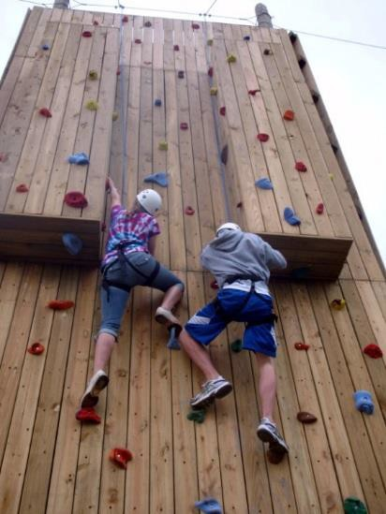
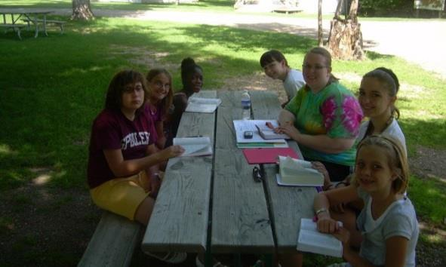
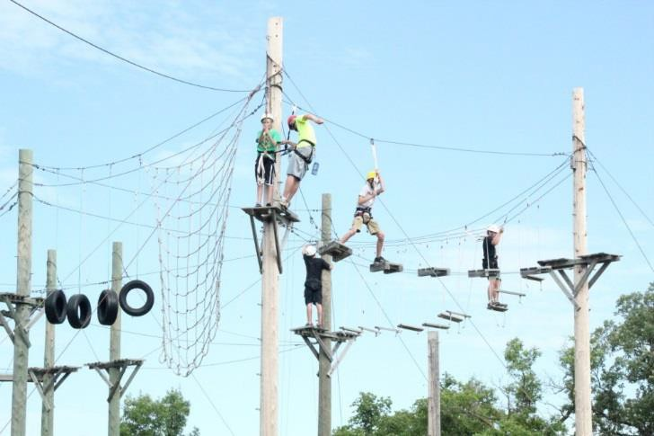
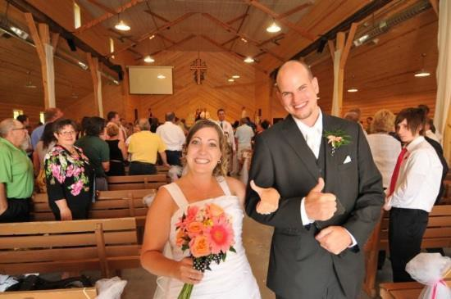
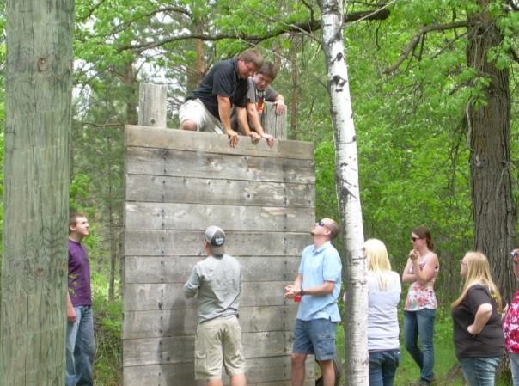
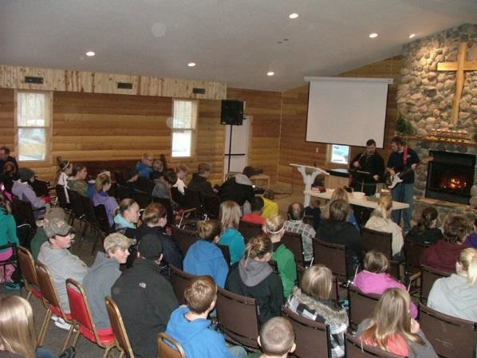
- 5 cabins, capable of sleeping 8-14 people each, 3 of which have bathrooms.

Outdoor and Seasonal Facilities
- 12 rustic cabins, capable of sleeping 9-11 people each.
- A craft center, amphitheater & campfire locations, Picnic area, Tent/camper sites, High/ Low Challenge Courses, Climbing Tower, Turbo Chute, Basketball, 4-square and Ga-Ga courts, Softball field, Disc golf course, Archery, Batting cage, Nature trails for hiking/cross- country skiing/snowshoeing

PAINTBALL!

Facility Rental Rates

Lodging and Meeting Rates

Overnight Package Rates (Includes: cabin and meeting space(s), Retreat Center Gym, use of general recreation equipment and a PRBC provided Retreat Host):
Package #1: One night lodging and three meals $74.00/person
$150.00 Group Minimum
Package #2: Two nights lodging and five meals $125.00/person
$200.00 Group Minimum

Non-package Rates:
Breakfast $10.00 Lunch $10.00 Dinner $10.00 Snack $5.00

Lodging – first night $62.00/person
Lodging – additional night’s $30.00/person Day Rate, not staying overnight $15/person

Primitive Tent/Trailer Camping:
Per day $ 10.00/unit
Per weekend $25/unit

Meeting Space Rental
Retreat Center and Conference Room Kitchen: $25.00/hour Fireside Room/Conference Room: $25.00/hour.
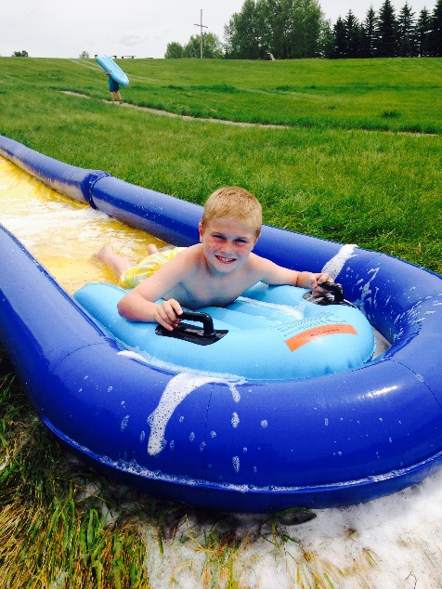

- Children under 5 receive meals and lodging free.
- Dining Hall Kitchen facilities are accessible to camp employees only, except for kitchen cleanup.
- Groups may schedule snacks to be prepared by camp staff. Prices are to be determined before arrival.
- The camp store stocked, with pop, candy, and other snacks as well as clothing, may be arranged to be open for business at the group’s request.

Special Activities by Request (made prior to arrival):

*Low Adventure Course $25.00/hour for a group of 10 People

*High Ropes Course $15.00/person w/overnight stay
(Minimum of 8 participants) $25.00/person w/out overnight stay

*Climbing Tower $15.00/person w/overnight stay
(Minimum of 8 participants) $25.00/person w/out overnight stay

*Canoeing
(Minimum of 10 participants) $50.00/per hour

*Paintball $35.00/session

*Archery
(Up to 12 people) $15/session

*Turbo Chute $25/session

*Challenge Course Health Forms are required for the High Ropes Course (available for those having finished grade 7 on up) and the Climbing Tower (available for grade 5 on up.) Challenge Course availability is dependent on the availability of PRBC facilitators. Facilitators are required for each Challenge Course.

Paintball Participant and Release Forms are required for all paintball participants.

Please visit our website for Challenge Course Health Forms, for Paintball Forms and for more information on all our activities, www.parkriverbiblecamp.org.

Other Activities (depending on the season): archery, hiking, fishing, disc golf, Ga-Ga, basketball, campfires, four-square, field games, cross country skiing, large group games. A small gym is also available for use during inclement weather.

Facility Rental Requirements, Recommendations and Policies

Requirements:

- Reservation Deposit – a deposit of $50.00 for every 25 people (or fraction thereof) will be required in advance. The camp facilities will not be reserved until this deposit has been received. This deposit is non-refundable if the retreat/conference is canceled by the renting group.

- Damages – Please report any damage, breakage, or anything found not to be in working order. Any damages must be assessed by a camp representative. The rental group will be expected to pay any repair or cleaning costs incurred by the rental group.

- Representative – There should be one representative from the retreat/conference group who is in charge of the retreat. He/she should handle pre-registration and all arrangements with Park River Bible Camp. He/she should be the first to arrive and the last to leave the camp.

- During regular camp season (June through mid-August), groups may not arrive before 3:00 PM Friday. Groups must check out by 11:00 AM Sunday.

- The group representative must notify the camp of the total number in the group at least 7 days in advance (for meal preparation purposes). Should this number drop, the retreat group will pay for meals according to the number specified rather than actual attendance. If attendance is larger than specified, retreat group will pay for actual attendance.

- If a serious medical emergency occurs, please fill out an emergency incident report and turn it in to the camp office.

Recommendations:

- Park River Bible Camp strongly advises that rental groups gather the following information:
  - Names, addresses, and health insurance information of all participants; Emergency contact names and numbers
  - A listing of any persons with known allergies or health conditions requiring treatment, restriction, or other accommodations while on site
  - For minors without a parent on site, signed permission to seek emergency treatment or a signed religious waiver.

- Park River Bible Camp also strongly advises that rental groups come equipped with adults who have the following qualifications:
  - CPR certification from a nationally-recognized provider
  - First aid certification from a nationally-recognized provider.
  - Have passed a criminal background check in the past 12 months.

- Park River Bible Camp highly recommends the following staff to camper supervision ratios:
- Kindergarten and Younger 1:5
- 1st to 8th Grade 1:8
- 9th to 12th Grade 1:10

Park River Bible Camp Policies:

- All rates are payable in U.S. funds only.
- The PRBC facility is rented on a first come/first serve basis.
- PRBC retains the right to refuse any group.
- No alcoholic beverages or illegal narcotics are allowed on camp property.
- Smoking is not allowed inside camp buildings. The designated smoking area is outside the Office Wing entry.
- All vehicles are to be parked in the parking lot. All signage is to be adhered to.
- Firearms, weapons, and ammunition may not be brought onto the camp property.
- Personal sports equipment like (but not limited to) archery equipment, bats, or throwing tomahawks should be stored and handled safely for the protection of all individuals. Rental Group leaders are responsible for knowing what is brought onto the PRBC facility.
- Pets and other animals are not allowed on camp property except for program purposes or in the case of guide animals. Exceptions may be made by the Director of Ministries. Animals and pets (including camp owned pets) are not allowed in buildings.
- First aid and medical attention are the responsibility of the rental group leaders. A basic medical kit will be made available. If requested access to the First Aid Station may be granted in order to lock medications brought by the group for safe keeping. Accessible refrigerators are available for items needing cold storage (i.e. insulin). Emergency transportation is the responsibility of the group. Emergency numbers are posted at all camp phones.
- Park River Bible Camp assumes the supervision of recreational activities only specifically arranged for in advance in writing.
- Except when specific activity leadership is being given, PRBC is not responsible for the supervision of rental group participants. PRBC strongly advises that supervision is planned for all minors at all times with a ratio not less than one adult for every ten minors.
- Group leaders and participants must attend an orientation to the camp’s safety procedures, rules, and boundaries near the beginning of the group’s stay at PRBC presented by a PRBC staff member. Rental groups should add this to the appropriate schedules.
- PRBC does not carry camper accident insurance for camp rental groups. It is recommended that rental groups consider appropriate insurance arrangements for/with the rental group’s participants and staff for the arranged event.

Group Rental/Retreat Agreement
(Please return agreement, along with deposit, within 7 days)

Group Information:
Group Name _ _ Contact Person __ _ Contact Home Phone Contact Business Phone Group Address _ Email Age/Type of Group _ Size of Group
Arrangements:
Arrival Date_ and Time_ _ Departure Date_ and Time
Please circle the meals and lodging you desire.
Meal times are 8:30 breakfast, 12 noon lunch, and 5:30 supper unless other arrangements are made.

Breakfast | M | T | W | H | F | S | S
Lunch | M | T | W | H | F | S | S
Supper | M | T | W | H | F | S | S
Overnight Lodging | M | T | W | H | F | S | S
(You are responsible for providing your own bedding)

Please list any special arrangements or specific requests the group has regarding meeting spaces, meals (including special diets), audiovisual equipment, recreational equipment and facilities (see the previous pages for more information on what is available):
_ _ _ _
_ _ _
_ _ _
_ _

After receipt of this form, a PRBC staff member(s) will contact the group representative regarding special requests or the use of recreational facilities and equipment.

By signing below, I state that I represent the group listed above and have read, understand, and will be responsible for all requirements, recommendations, policies, and fees listed on the previous pages of this agreement.

_
Group Representative Signature/Date PRBC Staff Person/Date

